TITLE :-JSP, Servlet and MySQL(Backend).

OBJECTIVES

1. Understand about basic concepts of html, CSS

2. Understand the basic functionalities of JSP

3. Having the knowledge of SQL query to create the database

PROBLEM STATEMENTS

1. Design and Build Student Login Page using JSP, Servlet and MySQL.

2. Design and Build Employee Login Page using JSP, Servlet and MySQL.

OUTCOMES

Students will be able to,

1. Develop a dynamic webpage using JSP, HTML and Servlet.

2. Write a server side java application called Servlet to catch the data sent from client, process it and store it on database (MySQL).

3. Write a server side java application called JSP to catch form data sent from client andstore it on database (MySQL).

SOFTWARE NEEDED

1. Any Operating System

2. JDK 7or later

3. Editors; Netbeans/Eclipse

4. Web browser

5. Tomcat 7 or later

THEORY - CONCEPT

Java Server Pages (JSP): It is a server side programming technology that is used to create dynamic web-based applications. JSP have right to use the complete Java APIs, including the JDBC API to access the databases.

It is a technology that helps software developers to create dynamic web pages based on HTML, XML and other document types. It was released in 1999 by Sun Microsystems. It is just like a PHP and ASP, but it uses the Java programming language.

A JSP element is a type of java servlet that is designed to accomplish the role of a user interface for a java web application. Web developers write JSPs as text files that combine HTML or XHTML code, XML elements, and rooted JSP actions and commands.

Using JSP, you can collect input from users through webpage forms, current records from a database or another source and create web pages dynamically.

JSP tags can be used for different purposes, such as retrieving information from a database or registering user preferences, accessing JavaBeans components, passing control between pages, and sharing information between requests, pages etc.

**Why we need JSP?**

JSP is used for the design of dynamic web page and servlet is used to code the logic that is present i.e. in the MVC (Model-View-Controller) architecture, the servlet is the controller and the JSP is the view.

Architecture of JSP

1. The request / response part of a JSP is defined in below architecture

2. The client initiated request for a JSP file using browser

3. Webs server (i.e, JSP Engine) invokes the JSP file and interpret the JSP file produce a java code. The created java code will be a Servlet.

4. Once Servlet is created, JSP engine compiles the servlet. Compilation errors will be detected in this phase.

5. Now servlet class is loaded by the container and executes it.

6. Engine sends the response back to the client.

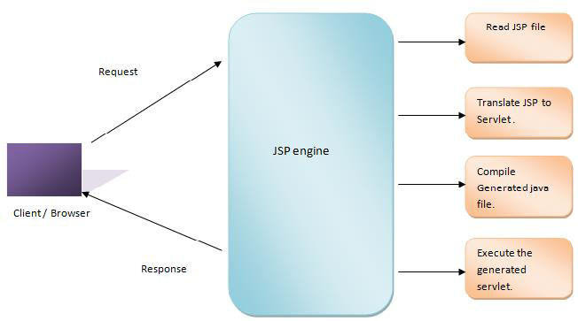

**Syntax of JSP:**

JSP declarations is used to declare variables and methods as shown below,

<% text %> Following is the simple and first example for JSP:

//Hello.jsp

<html>

<head>

<title> JSP File</title>

</head>

<body>

<%

out.println("Welcome to JSP Class");

%>

</body>

</html>

Output:

**Welcome to JSP Class**

**Servlet:**

A Servlet is a server side program and written in Java. Servlet is a web component that is deployed on the server for creating the dynamic web pages. A Java servlet is a Java program that extends the capabilities of a server. Although servlets can respond to any types of requests, they most commonly execute applications hosted on Web servers.

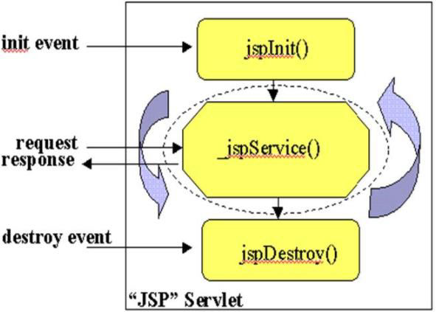v

**TECHNOLOGY/TOOL IN BRIEF**

1. JSPand Servlets

2. IDE: NetBeans 7.0 orLater

3. Databases: MySQL

**NetBeans:** NetBeans is an IDE, used for quickly and easily developing java desktop, mobile, and web applications, as well as HTML5 applications with HTML, JavaScript, and CSS. Also provides a huge set of tools for PHP and C/C++ developers. It is free and open source tool and has a great community of users and developers around the world.

**MySQL:** MySQL is a freely available open source Relational Database Management System

(RDBMS).It uses the Structured Query Language(SQL).

SQLis the most popular language for adding, accessing and managing data in a database.It is most noted for its quick processing, proven reliability,ease and flexibility of use.MySQL is an essential part of almost every open source PHP application.Good examples for PHP & MySQL- based scripts are WordPress, Joomla, Magento and Drupal.

**DESIGN / EXECUTION STEPS**

Followingstepsareusedto Create and Execute web applications,

1. Design html and jsp files with an extension of.html and .jsp

2. Write database connection pageusingservlet

3. Set MySQLusername, password and databasename in databaseconnection page

4. Start theTomcat Serverwith port number

5. Open the browser and typelocalhost:8084

**TEST CASES**

Manual testingis used tovalidate the fields like username, password, mobile number and email id’s of theusers entered byuser with the database.

**CONCLUSION / ANALYSIS**

Hence,wehaveperformed the dynamicweb application usingJSP, Servletand MySQL.